Assignment-4
Software Development Life Cycle and Software Testing Life Cycle

- Explain the various phases of SDLC.
Ans: Feasibility Analysis, Requirement Analysis, Design, Coding , Testing, Implementation and Maintanance.
1) Requirement gathering and analysis: Business requirements are gathered in this phase. This phase is the main focus of the project managers and stake holders. Meetings with managers, stake holders and users are held in order to determine the requirements like; Who is going to use the system? How will they use the system? What data should be input into the system? What data should be output by the system?
Finally, a Requirement Specification document is created which serves the purpose of guideline for the next phase of the model. The testing team follows the Software Testing Life Cycle and starts the Test Planning phase after the requirements analysis is completed.
2) Design: In this phase the system and software design is prepared from the requirement specifications which were studied in the first phase. System Design helps in specifying hardware and system requirements and also helps in defining overall system architecture.
3) Implementation / Coding: On receiving system design documents, the work is divided in modules/units and actual coding is started. Since, in this phase the code is produced so it is the main focus for the developer. This is the longest phase of the software development life cycle.
4) Testing: After the code is developed it is tested against the requirements to make sure that the product is actually solving the needs addressed and gathered during the requirements phase. During this phase all types of functional testing like unit testing, integration testing, system testing, acceptance testing are done as well as non-functional testing are also done.
5) Deployment: After successful testing the product is delivered / deployed to the customer for their use.
As soon as the product is given to the customers they will first do the beta testing. If any changes are required or if any bugs are caught, then they will report it to the engineering team. Once those changes are made or the bugs are fixed then the final deployment will happen.
6) Maintenance: Once when the customers starts using the developed system then the actual problems comes up and needs to be solved from time to time. This process where the care is taken for the developed product is known as maintenance.

- Explain the various phases of STLC
Ans: Test Planning and Control, Test Design, Test Implementation, Evaluating Exit Criteria, Test
Closure activities.

- Explain Traditional Software Development Model.
Ans: Traditional methodologies are characterized by a sequential series of steps like requirement definition, planning, building, testing and deployment. First, the client requirements are carefully documented to the fullest extent. Then, the general architecture of the software is visualized and the actual coding commences. Then comes the various types of testing and the final deployment. The basic idea here is the detailed visualization of the finished project before the building starts, and working one’s way through to the visualized finished structure.

- Explain Prototype Software development Model.
Ans: The basic idea in Prototype model is that instead of freezing the requirements before a design or coding can proceed, a throwaway prototype is built to understand the requirements. This prototype is developed based on the currently known requirements. Prototype model is a software development model. By using this prototype, the client can get an “actual feel” of the system, since the interactions with prototype can enable the client to better understand the requirements of the desired system. Prototyping is an attractive idea for complicated and large systems for which there is no manual process or existing system to help determining the requirements.
The prototype are usually not complete systems and many of the details are not built in the prototype. The goal is to provide a system with overall functionality.
Diagram of Prototype model:
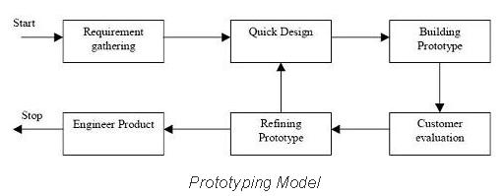
Advantages of Prototype model:

- Explain Iterative Enhancement life Cycle Model.
Ans: In Iterative model, iterative process starts with a simple implementation of a small set of the software requirements and iteratively enhances the evolving versions until the complete system is implemented and ready to be deployed.
An iterative life cycle model does not attempt to start with a full specification of requirements. Instead, development begins by specifying and implementing just part of the software, which is then reviewed in order to identify further requirements. This process is then repeated, producing a new version of the software at the end of each iteration of the model. The basic idea of this model is to start the process with requirements and iteratively enhance the requirements until the final software is implemented. Iterative process starts with a simple implementation of a subset of the software requirements and iteratively enhances the evolving versions until the full system is implemented. At each iteration, design modifications are made and new functional capabilities are added. The basic idea behind this method is to develop a system through repeated cycles (iterative) and in smaller portions at a time (incremental).
Following is the pictorial representation of Iterative and Incremental model:
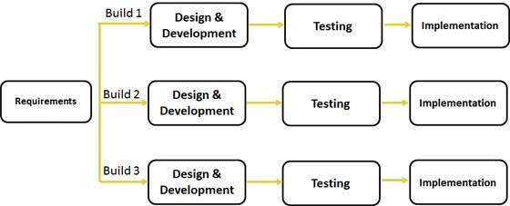

In incremental model the whole requirement is divided into various builds. During each iteration, the development module goes through the requirements, design, implementation and testing phases. Each subsequent release of the module adds function to the previous release. The process continues till the complete system is ready as per the requirement.

- Explain the various types of Maintenance Phase.
Ans: Variuous types of Maintenance Phases are:
- Corrective Maintenance - This includes modifications and updations done in order to correct or fix problems, which are either discovered by user or concluded by user error reports.
- Adaptive Maintenance - This includes modifications and updations applied to keep the software product up-to date and tuned to the ever changing world of technology and business environment.
- Perfective Maintenance - This includes modifications and updates done in order to keep the software usable over long period of time. It includes new features, new user requirements for refining the software and improve its reliability and performance.
- Preventive Maintenance - This includes modifications and updations to prevent future problems of the software. It aims to attend problems, which are not significant at this moment but may cause serious issues in future.

- What is the difference between High Level design and Low Level design?
Ans: High level design: Overall architecture of the application (e.g) data flow, flow chart, data structure. It is also known as macro level/ system design. Participants are design team, review team and client.
Low level design:
Detailed description of the each and every module. It is also known as micro level/ detailed design. Participants are only design team

- Explain V-Shaped Model.
Ans: The V - model is SDLC model where execution of processes happens in a sequential manner in V-shape. It is also known as Verification and Validation model. V - Model is an extension of the waterfall model and is based on association of a testing phase for each corresponding development stage. This means that for every single phase in the development cycle there is a directly associated testing phase. This is a highly disciplined model and next phase starts only after completion of the previous phase.

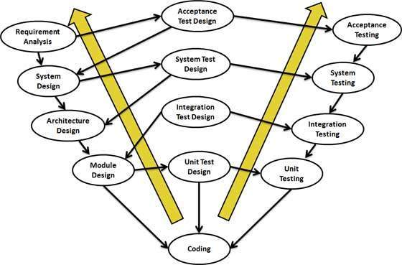
Verification Phases
Following are the Verification phases in V-Model:
- Business Requirement Analysis: This is the first phase in the development cycle where the product requirements are understood from the customer perspective. This phase involves detailed communication with the customer to understand his expectations and exact requirement. This is a very important activity and need to be managed well, as most of the customers are not sure about what exactly they need. The acceptance test design planning is done at this stage as business requirements can be used as an input for acceptance testing.
- System Design: Once you have the clear and detailed product requirements, it.s time to design the complete system. System design would comprise of understanding and detailing the complete hardware and communication setup for the product under development. System test plan is developed based on the system design. Doing this at an earlier stage leaves more time for actual test execution later.
- Architectural Design: Architectural specifications are understood and designed in this phase. Usually more than one technical approach is proposed and based on the technical and financial feasibility the final decision is taken. System design is broken down further into modules taking up different functionality. This is also referred to as High Level Design (HLD).
The data transfer and communication between the internal modules and with the outside world (other systems) is clearly understood and defined in this stage. With this information, integration tests can be designed and documented during this stage.
- Module Design:In this phase the detailed internal design for all the system modules is specified, referred to as Low Level Design (LLD). It is important that the design is compatible with the other modules in the system architecture and the other external systems. Unit tests are an essential part of any development process and helps eliminate the maximum faults and errors at a very early stage. Unit tests can be designed at this stage based on the internal module designs.
Coding Phase
The actual coding of the system modules designed in the design phase is taken up in the Coding phase. The best suitable programming language is decided based on the system and architectural requirements. The coding is performed based on the coding guidelines and standards. The code goes through numerous code reviews and is optimized for best performance before the final build is checked into the repository.
Validation Phases
Following are the Validation phases in V-Model:
- Unit Testing: Unit tests designed in the module design phase are executed on the code during this validation phase. Unit testing is the testing at code level and helps eliminate bugs at an early stage, though all defects cannot be uncovered by unit testing.
- Integration Testing: Integration testing is associated with the architectural design phase. Integration tests are performed to test the coexistence and communication of the internal modules within the system.
- System Testing: System testing is directly associated with the System design phase. System tests check the entire system functionality and the communication of the system under development with external systems. Most of the software and hardware compatibility issues can be uncovered during system test execution.
- Acceptance Testing: Acceptance testing is associated with the business requirement analysis phase and involves testing the product in user environment. Acceptance tests uncover the compatibility issues with the other systems available in the user environment. It also discovers the non functional issues such as load and performance defects in the actual user environment.

- What is the difference between functional spec. and Business requirement specification?
Ans: Functional Requirements are the functions that the system must perform in order to fulfill the Business Requirements. Thus functional requirements are connected with the solution or software being developed.
Business Requirements are high-level needs or wants of an organization the fulfillment of which allow the organization to achieve its objectives

- What is the difference between Testing and debugging?
Ans: Debugging is a process of line by line execution (White Box Testing) of the code/ script with the intent of finding errors/ fixing the defects. It is done by the Developer. It is nothing but fixing the bugs. Testing is the process of executing a program with the intent of finding an error.

